## **Exercise 1: Control Structures**

## **Scenario 3: Send Loan Due Reminders**

### **Aim**

Fetch all loans whose **EndDate is within the next 30 days** and print a reminder message for each customer.

### **Approach**

* Use a **Cursor FOR loop** to select loans due within 30 days.
* Use DBMS_OUTPUT.PUT_LINE to print a message for each.

### **📌 PL/SQL Code**

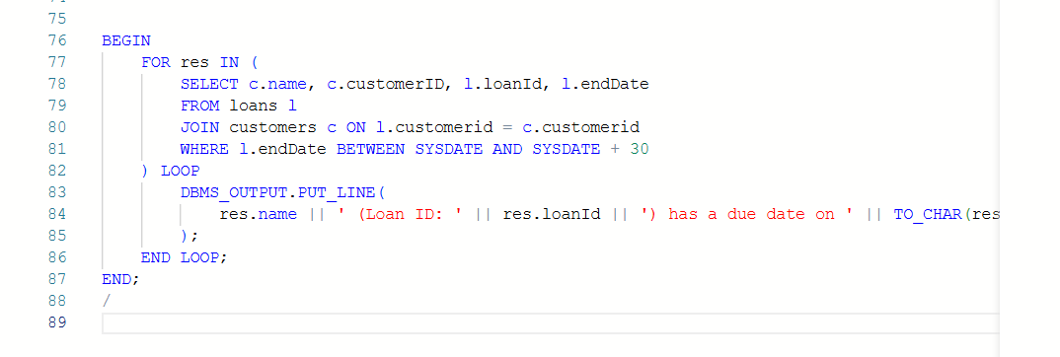

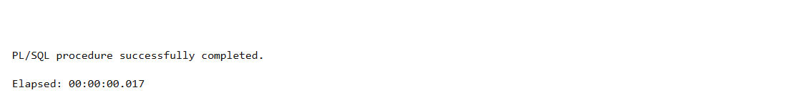

### **Result**

In the **DBMS Output**:

Reminder: John Doe, your loan of $5000 is due on 28-JUL-2025  
Reminder: Jane Smith, your loan of $7000 is due on 10-JUL-2025

